Name: Peter Ddamulira

Date: August 14, 2026
Assignment: Building a Web Page Exercise, Part 1
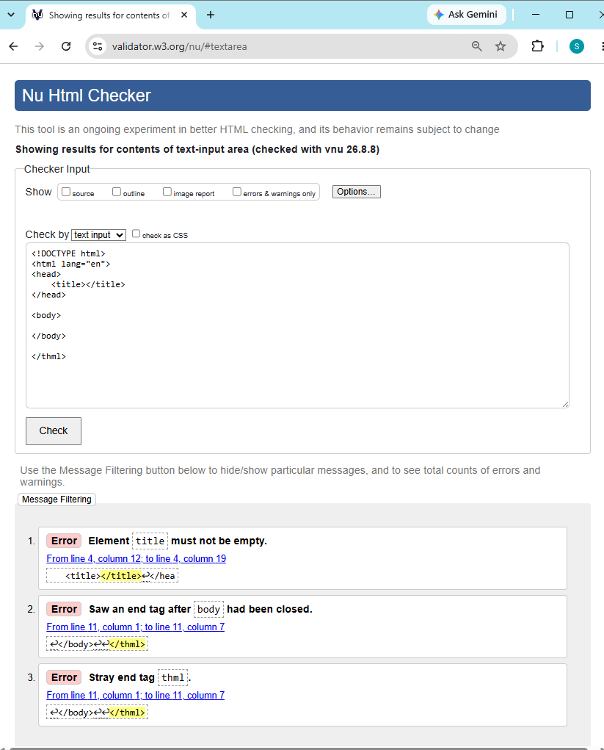
CSD340-300H Web Development with HTML and (2271-DD)
